**Challenge 7.**

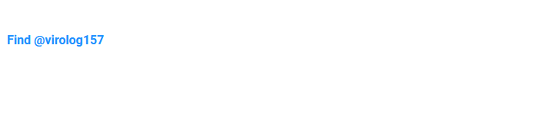

1. Not super detailed. I first inspect page source code. It appears there is nothing else on the page.
2. I turn to google to attempt and find out what @virolog157 means. Google just returns a bunch of stuff about virology. The closest I come is a few patents and a massive pdf (<https://www.jbc.org/article/S0021-9258(18)53375-5/pdf>) with the words:

53. Eaton, B. T., Hyatt. A. D., and White, J. R. (1987) Virolog 157, 107-116

1. I’m not thinking that is right so I keep looking. My next thought is social media. But nothing comes up there. No content for <https://twitter.com/virolog157>. Insta has a page, which is borderline a possibility, but also seemingly not:

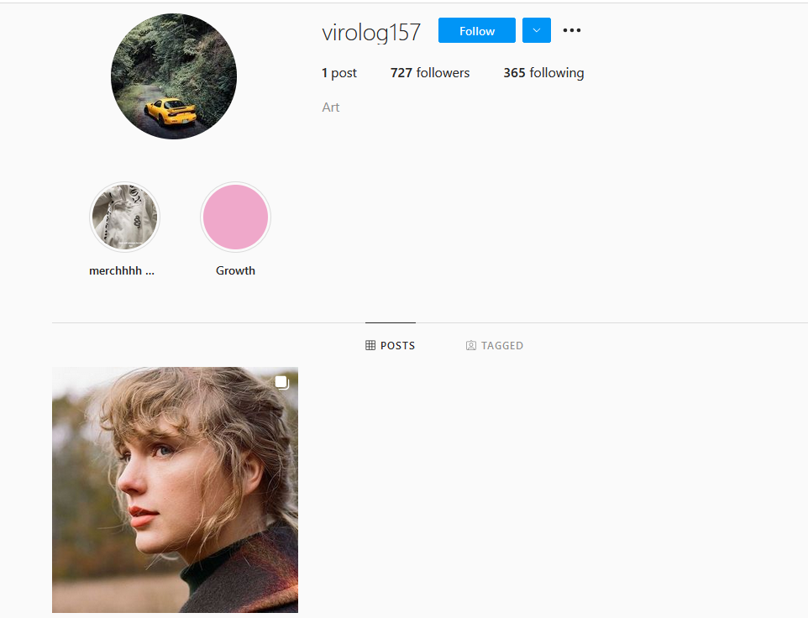

1. I also did a webscan against the site link and found 

Which gave me a 403 access denied. This in of itself is not unique but the fact that challenge 7 has no files offers a potential significance. Only some of the cyber challenges have /files/ folders. The rest actually have files.

1. Exiftool returns nothing noteworthy. The IPTC Digest/special instructions appear to be automatically added by Insta.